Brody Funk

Final

Visualizing info

The dataset I decided to pull from is the Indiana Pacers’ statistical data by player. The goal was to see each player's strengths and weaknesses compared to each other.

Some questions I developed were:

Which player excels where?

Which players are being underutilized?

Which players are being overutilized?

Who is contributing most to wins?

The first visualization I attempted was an octagonal skill graph. This was inspired by a soccer data website called FotMob which shows the strengths and weaknesses of individual soccer players. Here is a sketch of the initial plans.

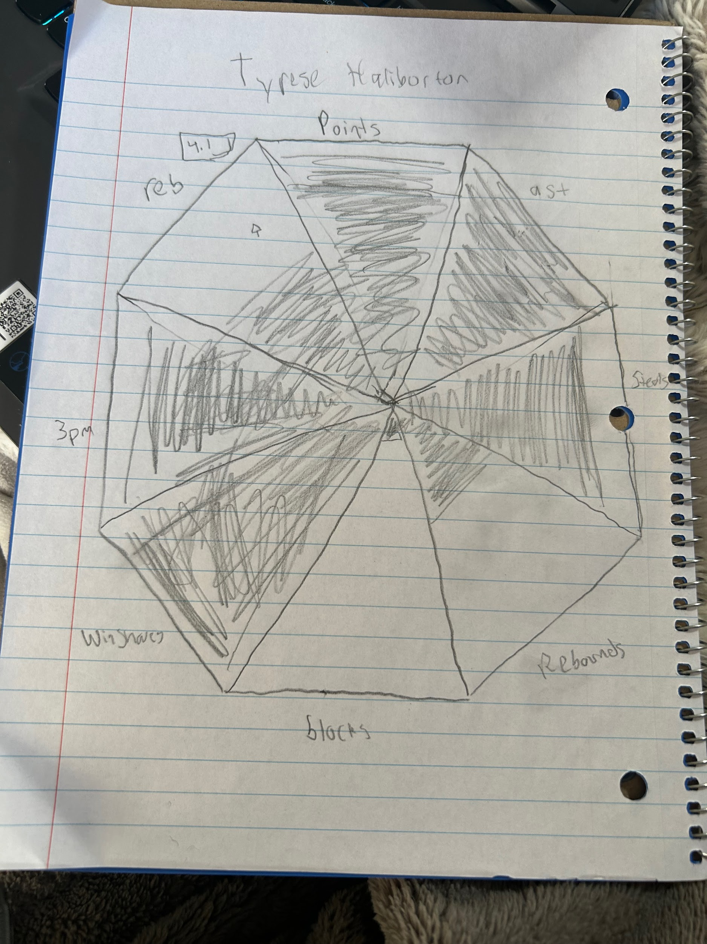

The goal was this graph for 12 players, where each stat's maximum would be the highest. When hovered over it would tell you the quantity of the stat. This graph was a little out of my skill range so I went back to the drawing board.

I initially sketched this pie chart that is supposed to represent each player’s part of the whole to see who is contributing most in each area. Same with my previous sketch this was meant to hover over to see the actual numbers. When I started coding this it seemed like there was too much going on so I revised it a little. Here is the first pie chart sketch and the second pie chart sketch.

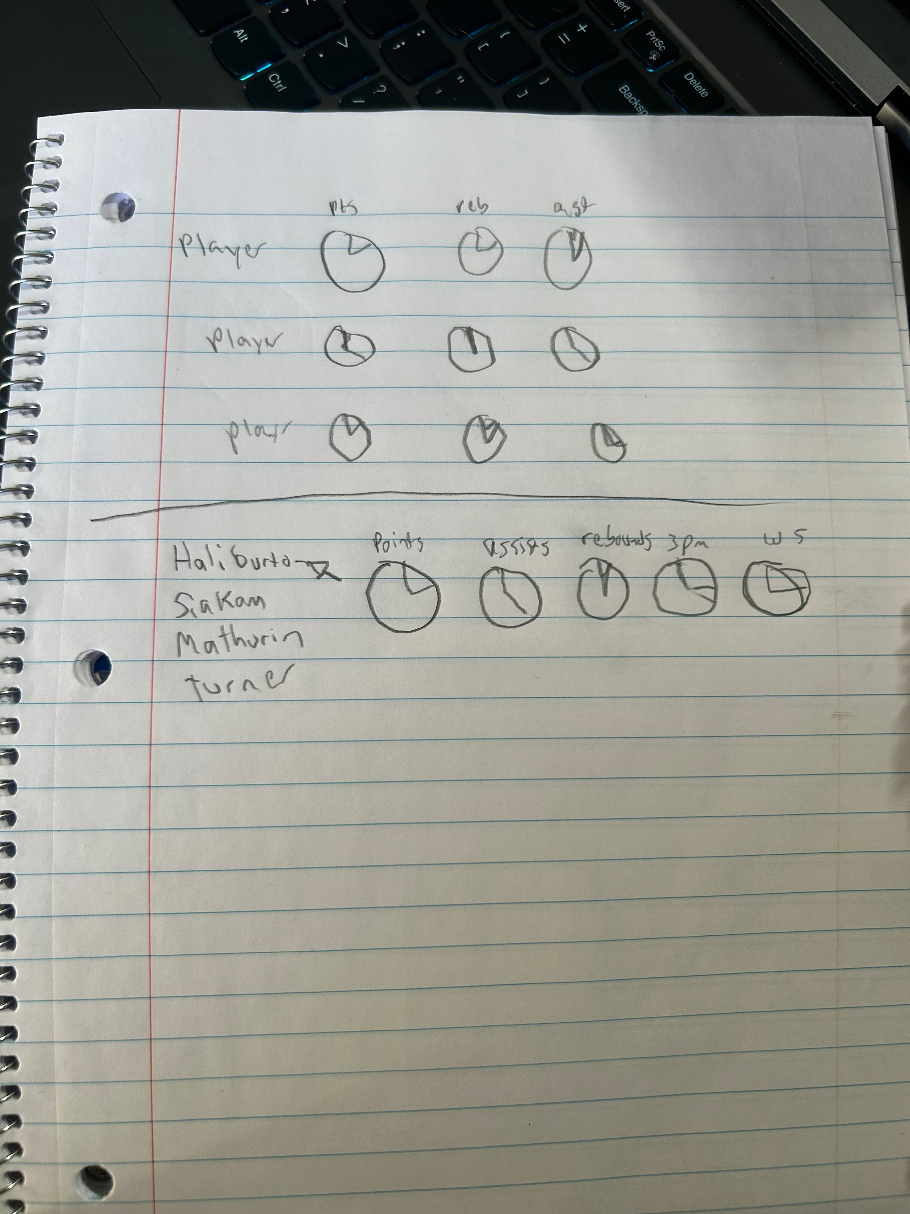

The second sketch was the one I decided to go with when you hover over the player you get their pie charts. This is easy on the eye and has useful interactions.

Some design choices I made while coding were to highlight the player’s name while hovering over so it is clearer who’s pie charts are being shows. I also chose blue and yellow for Pacers colors. The data I used were what I believed were the 5 major categories. All of the statistics are per 100 possessions besides win shares that are per 48 minutes. I decided to use these so I could find lower minute players with higher totals.

Some conclusions I can draw from this visualization is the Pacers starters struggle with rebounding, our team is pretty reliant on two players to generate assists with McConnell and Haliburton making up half the assists per 100 possessions. Based off of win shares the high minutes Nembhard and Mathurin may be a weak point, while Jalen Smith and Toppin are underutilized. Maybe the Pacers should add some better guard play with a lot of their guards having low win shares.

VIDEO

<https://youtu.be/eGSr5FQfxRE>